

**BTC2202 / ICS2014 : Computer Organization and Architecture**

**Assignment #2: Number Systems Usage in Computer Systems**

Gitonga Maryann Mwendwa 097770 ICS 2A

Imali Susan Lung’aho 109459 ICS 2A

Madafali Whitney Atonya 121289 ICS 2A

Felicia Chepngetich Bett 112306 ICS 2A

**Question (a): Results**

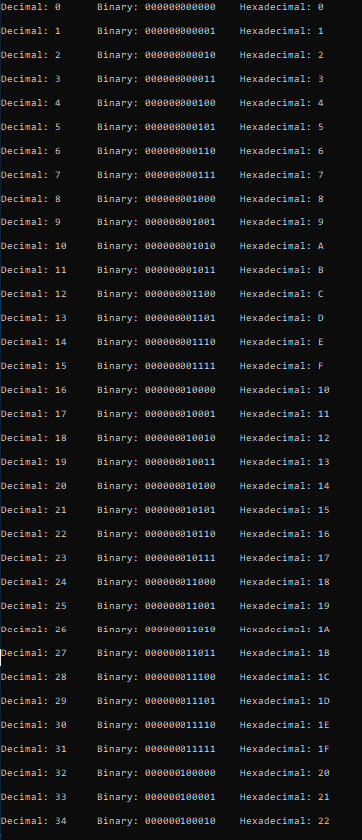

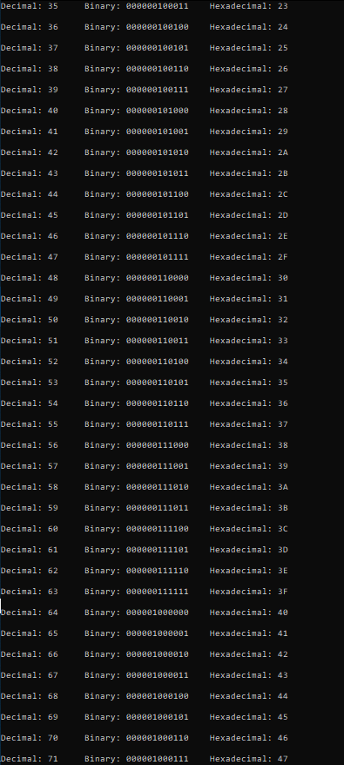

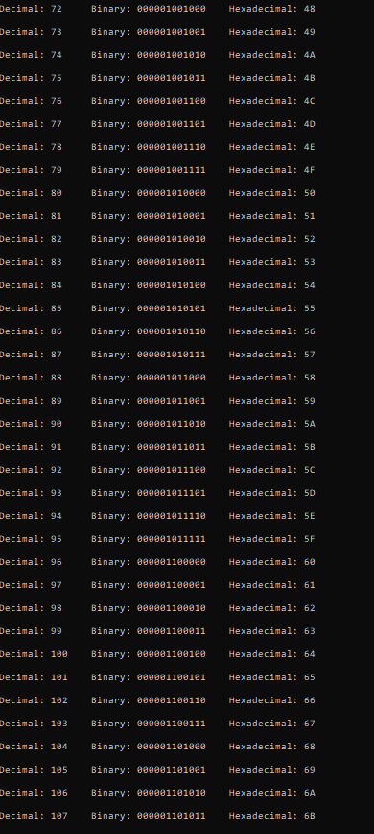

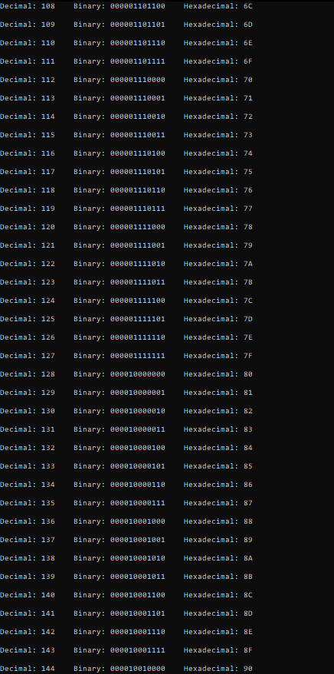

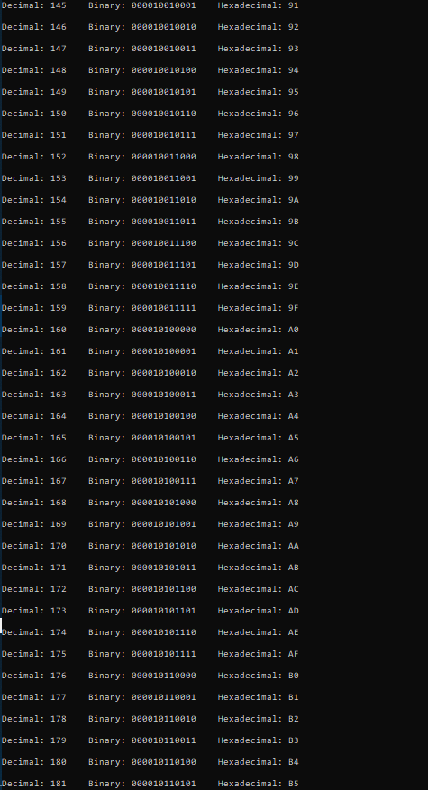

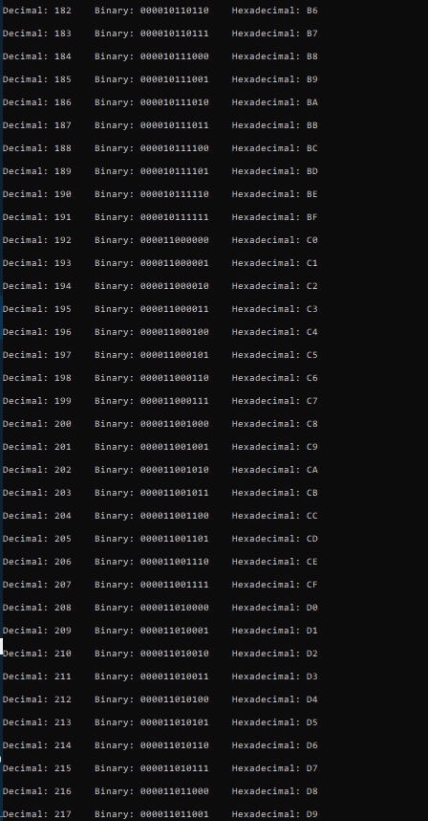

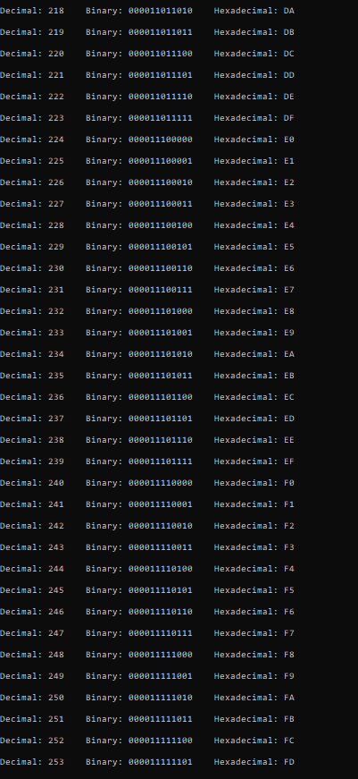

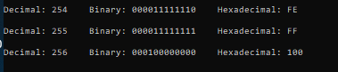

**Question (b): Results**

